In this project I have created a Restaurant Website in which I have used HTML, CSS, JAVASCRIPT to toggle and JQUERY property just to magnify the image.

Snapshots:

In **First** there is a name of the restaurant “MEAL CAGE” in title class of h1. Then there is a attribute again in class to give some css animation effects like duration with type, iteration_count, hover and opacity which named as “BOOK A TABLE”, This both written under “HEADER SECTION”. There is a navigation bar also with HOME, ABOUT, MENU, and CONTACT also in class to give effects written under “NAV BAR”.

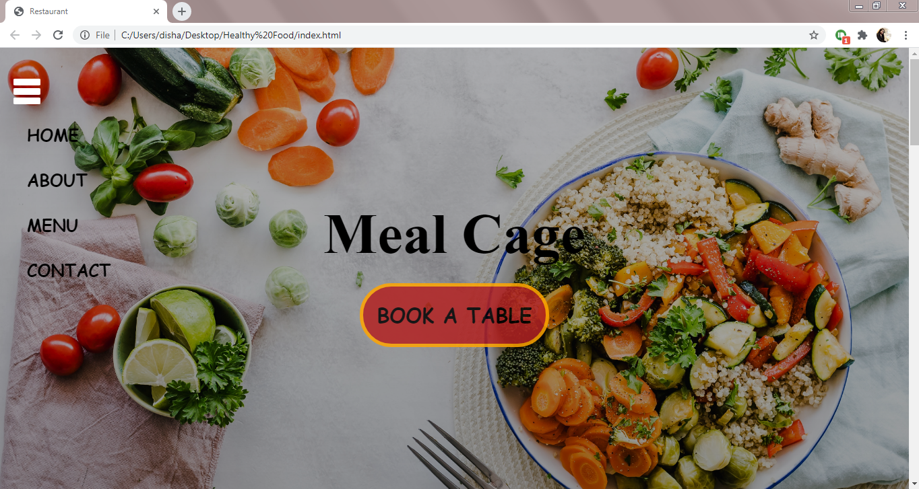

In **Second** there are total six articles, all re written in under “START OF THE ARTICLE” with the title-text named as “ABOUT US”. The name of those six articles are 1. Drinks – icon is fas fa-mug-hot, 2. Healthy Food – icon is fas fa-utensils, 3. Organic Food – icon is fas fas-mortar-pestle, 4. White Meat – icon is fas fa-meatball, 5. Sea Food – icon is fas fa-fish, 6. Hot & Spicy – icon is fas fa-pepper-hot. The icons are used in <i> element. There is a small definition also for all six in <p> tag just to define.

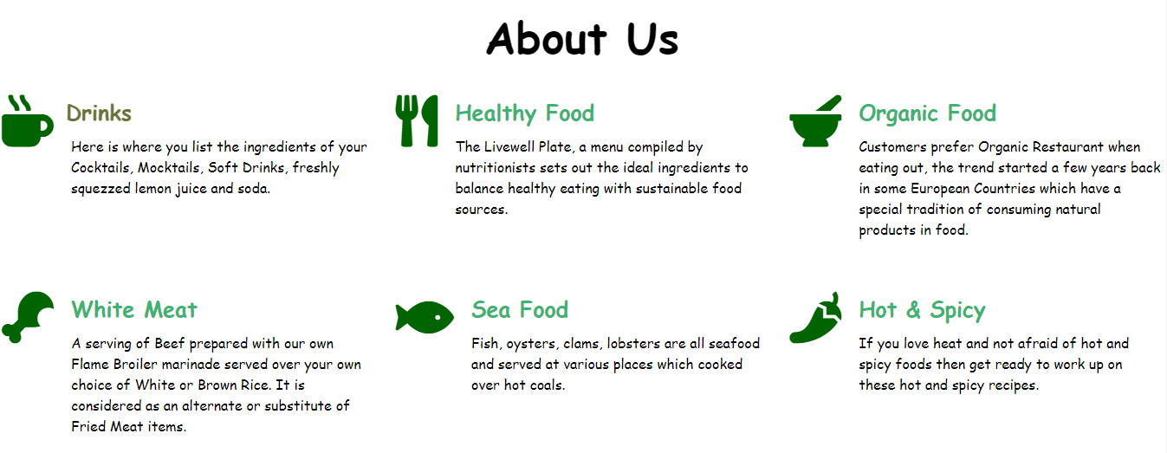

In this one, when we click on any of them in total six there will be a transition and transform effect in “2s ease” with **“saddlebrown”** color. In this ss effect is on **“ORGANIC FOOD”.**

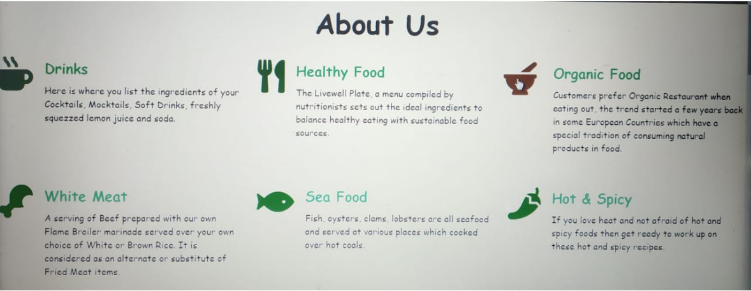

In **Third** there is a definition of Menu or a-la-carte named as “OUR MENU” with the attach of menu image in left which is written under “MENU SECTION” Also When we click on “EXPLORE” it will take to the “HEADER SECTION”.

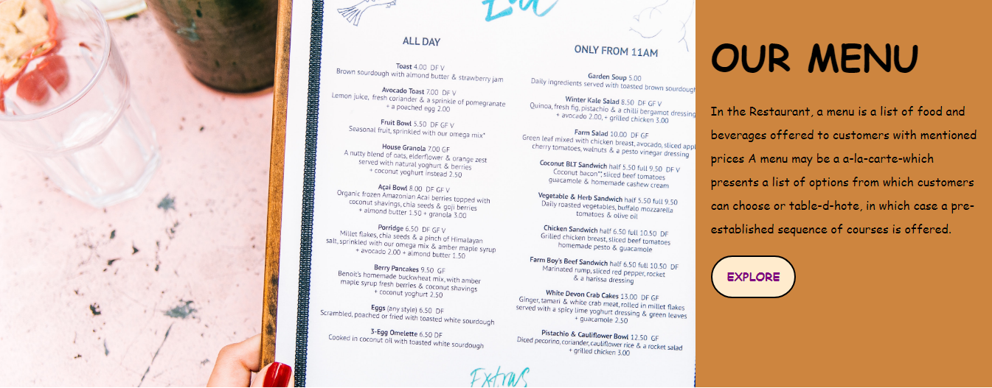

In **Fourth** there are total four social icons – 1. “Facebook” – icon is fab fa-facebook, 2. “Twitter” – icon is fab fa-twitter, 3. “Instagram” – icon is fab fa-instagram, 4. “Googleplus” – icon is fab fa-google-plus which are written under “SOCIAL ICONS”.



In **Fifth** there are total six icons – 1. “Breakfast Bread” – icon is fas fa-bread-slice, 2. “Pizza” – icon is fas fa-pizza-slice, 3. “Cheese Variations” – icon is fas fa-cheese, 4. “Meat Dishes” – icon is fas fa-cloud-meatball, 5. “Egg Special” – icon is fas fa-egg, 6. “Dessert” – icon is fas fa-ice-cream with a number written in <p> tag written under “Numbers” with a background image.

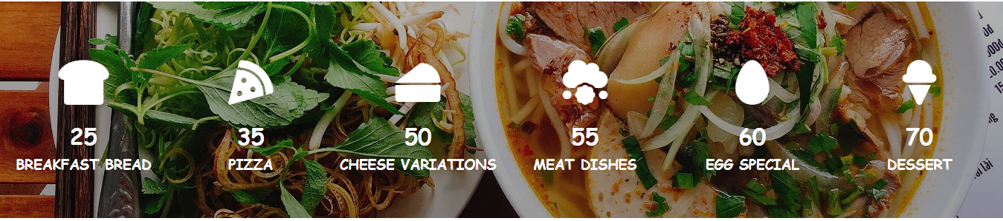

In this one, when we click on any of them in total six there will be a transition and transform effect in “3s ease” with **“maroon”** color. In this ss effect is on **“CHEESE VARIATIONS”.**

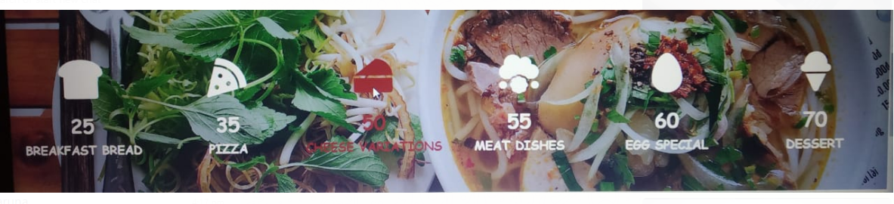

In **Sixth** there are three meals “BREAKFAST ”, “LUNCH”, and “DINNER” written in<h1> tag with a different background image for all three. When we move cursor to the image it shows the amount which has written by using fas fa-dollar-sign and also a button of “ORDER NOW” with different color for text and different background-color named as “FOOD FUSION” written under “CARD SECTION”.

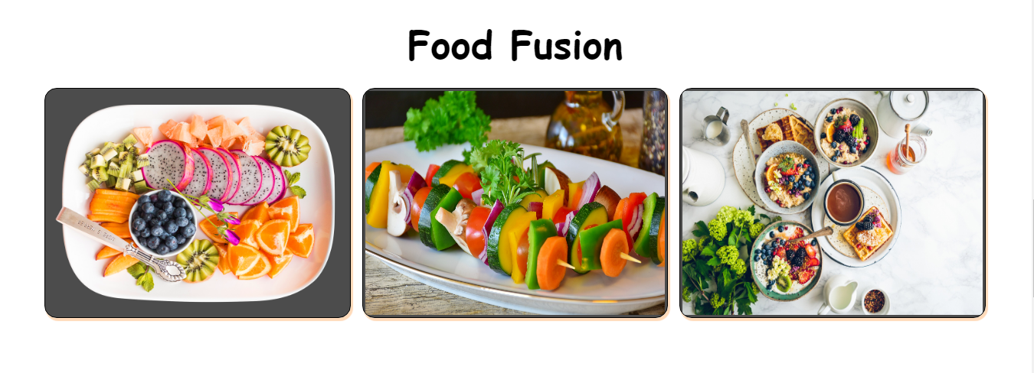

In this one, when we click on any of them in total three there will be a transition and transform effect in “5s ease” with **“red”** color on text and background color is peachpuff. In this ss effect is on **“LUNCH”.**

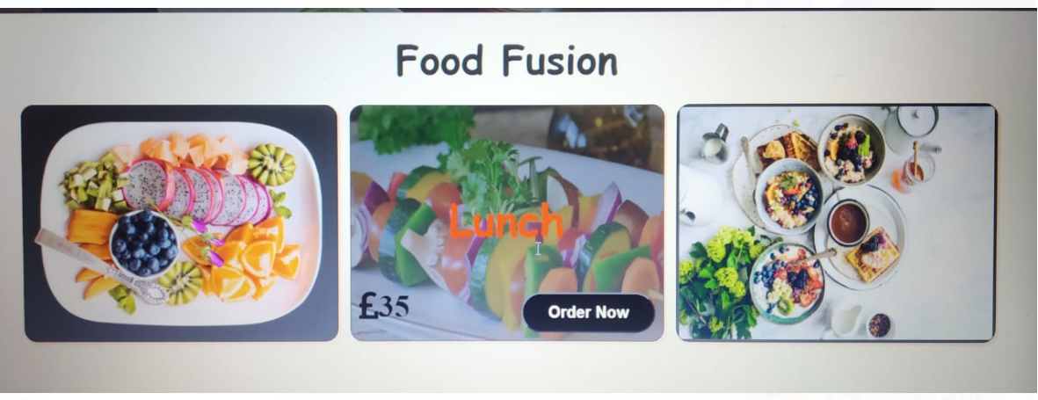

In **Seventh** there are some images of Restaurant, Meal, Beverages to show the JQUERY property which I have used to magnify the image when click on it named as “MAIN CUISINES” written under “GALLERY SECTION”. A footer is also add in website same of restaurant name “MEAL CAGE”.

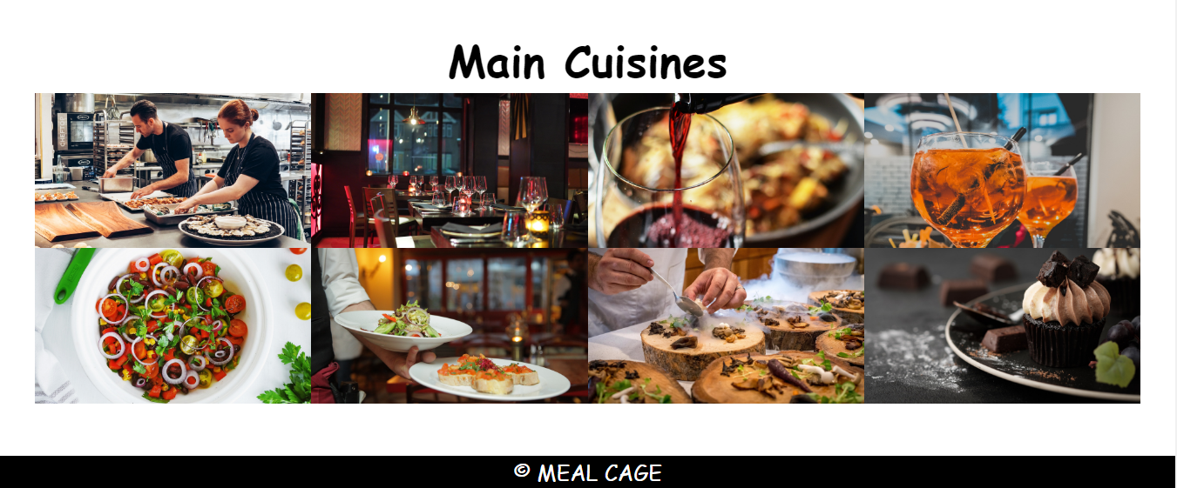

**“WHEN WE CLICK ON ANY OF THE IMAGE”**

